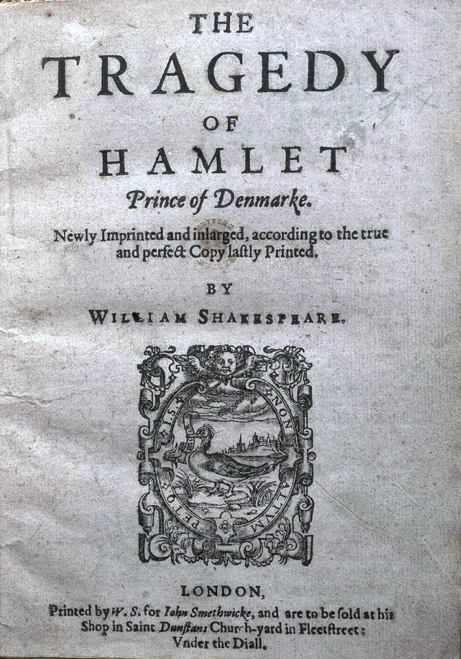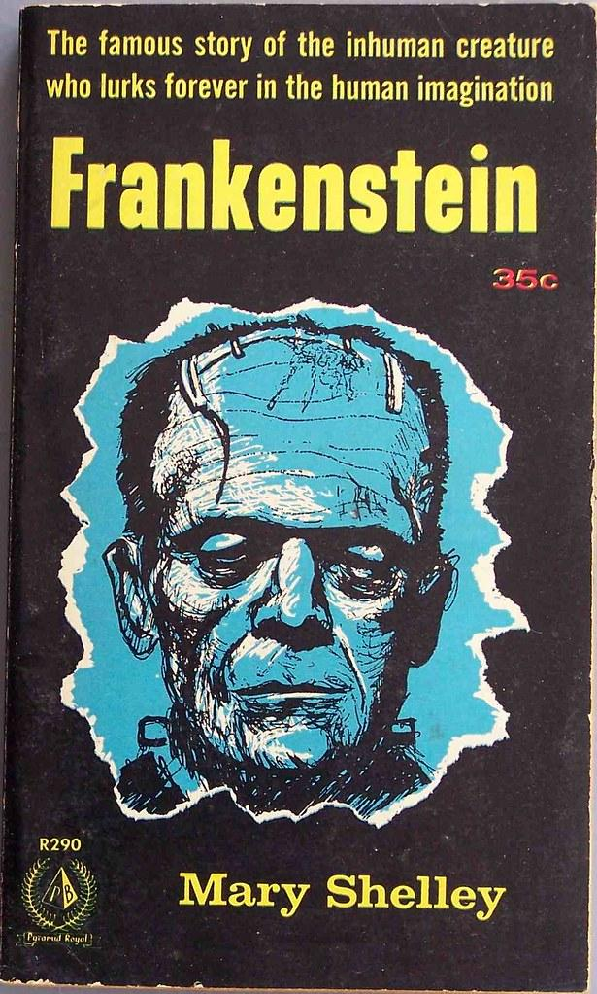
Course: English IV
Instructor: Mrs. Casey Allen, M.A
Conference Hours:10:25-11:55 A Days only.
Tutorial Times: M-F 7:30-7:55
M-F Homeroom
M-F After school; Please make arrangements before staying after school with me so I know how long you’ll need to stay.
E-mail: allenc@hooksisd.net or casey.allen@gohornetsgo.net (Google Classroom)
Course Description: This course is going to be devoted to writing and the craft, analyzing literature and (hopefully) enjoying literature, and formulating thinking beyond the text and into our world. We will be using this course as an introduction to college/real world readiness writing and the writing process. This course is aligned with the TEKS standards that will allow us to prepare for life after high school. The writings you do in class will be supplemented with additional readings, lectures, and discussions.
Goals of the Course: Our goal for this course is to stretch our writing/reading/thinking muscles and finely tune the skills necessary to become productive citizens within our schools, jobs, colleges, and communities. Just as an athlete must train for his/her sport, writers and academics must also practice, practice, practice.
Professional Expectations
As seniors in Hooks High School and future professionals, we will be practicing professionalism in the classroom. Some guidelines to follow are:
- Be Respectful.
  - Listen to your teacher. Listen to your classmates. Wait your turn to talk.
- Be Responsible.
  - Use the restroom before class starts. Come to class on time. Have your supplies and be ready to learn! Participate in your partners or groups.
- Be Honest.
  - Plagiarism and copying are forms of academic dishonesty. And better yet, it’s a way of lying to yourself. You ARE able to achieve ANYTHING.
  - If you don’t understand something, be honest with me so I have the opportunity to help and to get better, too.
- Be Polite.
  - Use kind words. Do no harm. Keep your hands and other items to yourself. Try to express yourself in a nice way. You are allowed to disagree, but please respectfully listen to others. No rude comments allowed.
- Follow the School’s Rules
  - There may be things in the handbook that you disagree with, but we’re still responsible for keeping those codes of conduct.
  - No food allowed in class.
  - Clear water bottles only.
  - No cell phones unless the teacher explicitly says otherwise. ALWAYS ASK FIRST, AND IT MUST BE FOR ACADEMIC REASONS.
- Attendance Policy: Please be in class. If you must be gone, work must be made up in a timely manner. If you know you will be absent, get the work ahead of time. If you become ill or have an unfortunate happening that is beyond your control, please get the work either by emailing me or by getting it as soon as you come back. You will only have the days missed plus 1 to get things finished and turned in without penalty.
- Bathroom Breaks: Go before you get to class. Bathroom passes are 3 per 6 weeks and must be kept at no longer than 5 minutes. Students should not interrupt lessons to go to the restroom.
- Conduct yourself in ways that make parents, teachers, administrators, and community members proud. We are watching.
- Plagiarism will not be tolerated, and the consequences of plagiarism are severe in both academic and life settings. I want to hear what YOU have to say, not what somebody else has to say. When we do our research, please be sure to cite sources!
  - pla·gia·rism [pley-juh-riz-uhm] noun 1.an act or instance of using or closely imitating the language and thoughts of another author without authorization and the representation of that author's work as one's own, as by not crediting the original author. Synonyms: appropriation, infringement, piracy, counterfeiting; theft, borrowing, cribbing, passing off.
Cheating off of another student is also considered plagiarism. If I find that students share work, those students will share the grade. So, if my friend and I copy each other and we both make a 70%, I will get a 35% and so will my friend. Then my parents/guardians will be called or emailed AND I will have to write an apology letter to my teacher, my friend, and my principal for being dishonest.
Cell Phones/Devices
Cell phones are not permitted in class UNLESS it is in the lesson plans and your teacher tells you to access your phone/device. During that time, you may only use them for what the teacher asks you to use them for. No texting, calling, gaming, taking selfies or pictures of others, Instagramming, facebooking, tweeting, Snapchatting, etc. NOTE: did you know that taking photos of people without their knowledge or permission is illegal?
Anyone caught using a cell phone without permission will have their phone taken to the front office per the student handbook.
Please note that I am not responsible for lost or stolen phones that are left in my classroom if you chose to charge them. Students will be responsible for keeping up with their devices.
Assignments: In order to make an A in this class, you must complete all assignments. Students will receive a minimum of 10 grades each six weeks for daily work, class participation, quizzes, essays, and projects. Tests, essays, and projects will count for more and will be announced in advance.
Late work will be penalized if it is late. If it is a week or more late, it cannot get more than 70%. It is your responsibility to find out what you missed and get the daily notes from a classmate. You will have the number of classes missed, plus one to complete the assignment(s).
If you don’t finish work in class, be responsible enough to take it home for homework or come to tutorials to complete unfinished work.
We have several units covering the very beginning of the English language (Old English) literature through Middle English, Elizabethan English, and then into Modern English. Some of our works will include:
- Beowulf
- Canterbury Tales by Geoffrey Chaucer
- Hamlet by William Shakespeare
- Frankenstein by Mary Shelley
- We will also cover different periods of poetry and other forms of literature!
We will also explore informational text and other forms of writings that meet the TEKS.
Grading Scale:
A—90-100%
B—80-89%
C—70-79%
D—60-69% and ineligible for extracurricular activities
F—below 60% and ineligible for extracurricular activities
If you have any questions about the grading scale or your grade in the class, please feel free to ask me after class.
Book Club/Independent Reading Time:
Each 6 Weeks Grading Period will consist of a Book Club. Students will self select a novel THEY are interested in. Students will be given reading deadlines and will be graded on small group discussion/participation and ability to convince me you did the readings. You may do this in a small group of 2-4 people, or you may read independently.
Texts/Books: All of the texts that we will be using this semester will be available in class. Most of our reading will be in the classroom, but some will be outside reading. When outside reading is required, a book will be checked out to you. If you harm the book or lose it, you will be required to provide money for a replacement.
Supplies:
You will need—
- Headphones that connect to the chromebook (when needed). You will keep these.
- College Ruled notebook or paper (If you get loose paper, I HIGHLY suggest a binder to keep it in.)
- Pencils or pens
- Planner or printable planner pages in a binder
- Optional:
  - Hand sanitizer
  - Box of tissues
  - Non-bleach cleaning wipes or bottle cleaning spray
  - 1 inch binder to keep you organized. This one isn’t mandatory, but HIGHLY recommended.
If you have trouble getting supplies for class, let me know so that I can get you those things.
Class Schedule: In your planner, you will write down due dates, homework, etc. I will do my best to get a calendar with the upcoming assignments on it each month. However, please know that the calendar is subject to change if something comes up in class. Things can be added and taken away at my discretion.
IF STUDENTS ARE TAKEN OUT OF CLASS, students are STILL responsible for that day’s assignments/reading/writing. Meetings, assemblies, etc. do NOT mean that we put that off for another day.

Parent Information Sheet

After reading and reviewing the English IV course syllabus, please complete and return the Parent Information sheet to Mrs. Allen.

Please sign if you have read and understand the class syllabus.

Student’s Name: ____________________________________________________

Student’s Birthday: _________________________________________________

Parent/Guardian’s Name:______________________________________________

Parent/Guardian’s E-mail Address: ______________________________________

Parent/Guardian Phone Number: ________________________________________

Questions or Comments:

Things you would like Mrs. Allen to know about your child:

